**CHAPTER ONE**

1. **INTRODUCTION**

Asset management, to be more specific, controlled asset management, is a very meaningful activity in any organization. A general definition of asset is: all non-consumable goods with a unit value in excess of X dollar amount, usually established by the organization, and with a useful life of one year or more (UCAR Property Manual, 2002). Proper asset management establishes and maintains a current inventory of this type of property within the company. By doing so, the institution ensures responsibility and accountability of these assets, in addition to the efficient and effective use of them. Furthermore, a good asset management program can facilitate the physical inventory process of assets, establish their insurance condition and comply with federal, state and local policy. Thus, Asset can be defined as property and items that have commercial value owned by a person or business. The primary classifications of assets are: current assets, long-term assets, prepaid and deferred assets, and intangible assets.

Asset management is a business discipline, which describes the management of technical infrastructure for business operation. Asset management entails managing company’s property and investment for people and company as well, using a more technical and result oriented approach with detail report and economic forecasting on finance and wages.

Asset Management Software easily automates the whole process of asset management from asset documentation, stocks, hardware and software management, assigning asset to staff and managing categories as well. System users are created by the system admin where each staff is able to login in with the provided authorization and manage asset registered on the system. The admin has the sole authority over the system.

**1.1 Background of the Study**

Today, companies have a large quantity of assets. To provide better service and to be more efficient, organizations are always acquiring more assets. Every company and/ or organization in today's economy needs to keep up with the ever changing technology to contribute to meeting market expectations. Better and improved assets can make organizations more valuable because of their use and the benefits that these assets provide. For example, faster service and better support to a company's operations can help provide a better quality service to the organization's customers. Institutions, worldwide, need assets and management processes to control how these items are purchased, store and utilized by the firm. Assets are high cost items; this is a reason why all companies need to manage their assets in an organized manner. Many microfinance banks have assets inventory management system, which helps them ensure proper control and management of their assets. The improper management of an organization's assets can have a negative effect on the institution for example, hidden costs associated with excess of assets. The asset management system being used in RALPH OLARK ventures has failed to live up to the requirements of the existing asset scenario. The ability to access and process information quickly while displaying it in a spatial and visual medium makes staffs to go through a lot of stress to allocate resources quickly and more effectively.

The current system of asset management system in RALPH OLARK ventures is associated with following problems:

1. In the manual system, the speed of operation was found to be relatively slow.
2. quick search on the database to retrieve asset information
3. Loss of the complete asset records as a result of mishandling in the case of transfers of document (records)

Therefore, there is a need to develop and implement a computerized asset management system that will eradicate data redundancy and ensure speedy.

**1.2 Statement of the Problem**

This research work was undertaken to uncover some of the problems with conventional Asset management systems. Here asset manager manages several company and persons, he/she achieve this by taking proper documentation and record keeping, these records grow with time and ease of use as well as retrieval of information becomes tedious. Access to sensitive information or portfolio becomes grueling. Using these conventional method pose lots of constraint on managers has he/she has to move around with large files always to be able to have first-hand access to info on demand. These slow work process and affect rapid growth in an establishment.

**1.3 Aim and Objectives of the Project**

The design and implementation of Automated Asset Management Information system will help to provide the manager the information needed i.e. the asset that sells most in an area.

1. To Develop and implement an Automated asset management information system
2. To implement the design system in (i) above Using Vb.net and Dev express 12.0
3. To evaluate the performance of the newly developed system based on user accessibility

**1.4 Significance of the Project**

The implementation of this work will help in the proper management of fixed and controlled assets in order to avoid hidden costs associated with the mismanagement of this type of property. A new management process will support decisions when buying, eliminating or assigning assets within the organization.

* 1. **Scope of the Project**

This project is centered on asset management system for RALPH OLARK ventures. This project will be implemented to ensure that all fixed and controlled assets are registered, tagged and Identify where these assets are located. This helps the management to determine the overall cost of their fixed and controlled assets.

**1.6 Research methodology of the Project**

The methods of study employed in this project work are as follow:

1. An establishment of a theoretical foundation for the project work through a sound review of relevant literatures on asset management system. The team carried out preliminary studies to define the tasks. Asset management on procedures is elicited by observation and inquiry from management and general studies was conducted.
2. The design of asset management system using VB.Net and dev express 12.0 programming language
3. The implementation of asset management system using VB.Net and dev express 12.0 programming language
4. Evaluation of the performance of the newly developed system based on Problem of the existing system

**1.7 DEFINITIONS OF TERMS**

**Controlled Assets:** All non-consumable items with a value of less than "X" amount and a useful life of a year or more, but need to be controlled as regular fixed assets because these items are considered to be highly susceptible to theft or misuse.

**Location:** Refers to the current physical location of assets.

**Asset Number:** Is the number assign to an asset as soon as it is registered it can be done with a barcode system.

**Cost:** The real value of assets after depreciation.

**Time or date of acquisition:** Time evaluated in months or years of the initial purchase of the asset, date of acquisition.

**Insurance:** Coverage by contract whereby one party agrees to guarantee another against a specific loss.

**Maintenance:** The provision of support or repair of assets.

**Inventory:** The act or process of making an inventory, or the period of time when this is done.

**Depreciation:** The lessening of price or value of an asset over time.

**Computerization:** This is the conversion of a manually operated system to a controlled, organized and automated system.

**CHAPTER TWO**

**2.0. LITERATURE REVIEW**

Literature review is an account of what has been published on a topic by accredited scholars and researchers. It also text of scholar which includes the current knowledge including substantive findings, as well as theoretical and methodological contributions to a particular topic

**2.1 INTRODUCTION**

Companies worldwide have assets to support business operations. These assets are an essential part of every business. Sometimes asset management can be difficult if there are not policies and procedures in place. Assets affect myriad aspects of financial planning, reporting, and control. Many discrete, complicated, and time-dependent tasks comprise asset management. In addition, the slightest error can have drastic effects. This chapter will present a literature review to better explain the importance of assets management, and how important these assets are to an institution.

**2.2 ASSETS DEFINITION**

Assets are non-consumable goods, tangible in nature and have a useful life longer than one year. According to William D. Brady, Jr. (2001), "it can be any item costing over a certain dollar amount, large or small, to an item that has a certain useful life." These assets are classified as land, improvements other than buildings, operating plants, equipment, vehicles, and construction in progress (Peterson, 2002). Assets can be both movable and immovable. Items of insignificant value, while they meet the above criteria, are normally expensed instead of being considered assets.

For profit and non for profit organizations, such as universities, are required under GAAP, General Accepted Accounting Principles, (Delaney, Epstein, Nach and Budack, 2002) to maintain a ledger or group of accounts in which to record the details relating to the general assets of the organization.

Establishing and maintaining complete and accurate accounting records for assets is important for several reasons as stated by Brady (2001). First, the value of assets is large in most organizations. Therefore, adequate accounting procedures and records are essential for effective property management (including risk management) and control. Second, the stewardship responsibility involved in safeguarding such a large investment is of the utmost importance for good financial administration. Third, adequate assets records can assist in making management decisions. Proper use of these records may prevent unneeded assets from being purchased. Asset records also could be used to help clarify long-term capital budgeting needs. Finally, accurate and complete assets records can prevent the possible misstatement of the institutional financial statements for assets. Otherwise, assets such as those acquired under capital leases and joint ventures could be overlooked.

**2.3 CLASSIFICATION OF ASSETS**

Assets should always be recorded in the accounting records of an institution. Accounting classifications of fixed assets accounts are as follow (Heintz & Parry, 2002):

**1. Property**

**Land** - Assets account that reflects the acquisition value of land and the rights to land owned by the organization. It includes all land held in fee simple and all rights to land that have no termination date.

**Improvements Other Than Buildings** - Assets account that reflects the acquisition value of permanent improvements (other than buildings) that add value to the land or improve the use of the land. Examples of such improvements are: fences, retaining walls, drainage systems, sidewalks, parking lots, and driveways. It is good to make clear that the term improvement and betterment have different meanings when used with assets. Improvements are fixed assets permanently attached to land. Betterments are additions to or changes in existing depreciable assets intended to increase their efficiency or prolong their useful lives. Recording of this type of assets in the accounting records is optional. This category of assets is immovable and of value only to the institution (US Department of Housing and Urban Development, 1999).

**Buildings**- A assets account that reflects the acquisition value of permanent structures owned by a business to house persons and property. Permanently installed fixtures to or within these structures are considered parts of the structures. The cost of major improvements to structures is included in this account.

**2. Plant**

**Operating Plants**- A assets account that reflects the acquisition value of plants used to provide the services of utilities, including both the building and the equipment

**3. Equipment**

**Equipment**- A assets account that reflects the value of tangible property not permanently affixed to real property, used in carrying out the operations of the business. Examples of equipment are machinery, furniture, and vehicles. This project will specifically examine and recommend a new process for the management of equipment

**2.4 RECORDING ASSETS**

Business may acquire assets by several methods. Possible acquisition methods include purchase with a Purchase Order or PO, lease-purchase, installment purchase, construction, and gifts. The method of acquisition of assets should be properly recorded on the books of account and in subsidiary records that provide detailed information on each asset in an article published in Management Accounting: Magazine for Chartered Management Accountants, Stephan Moriarty (Moriarty, 1998) says that "a lot of financial managers do not have accurate information about what their companies own (pg 42)", and continues explaining how important it is to record assets in the appropriate books.

There are many rules and regulations on what and how assets should be recorded. To avoid recording many assets with low values that do not, in the aggregate, amount to a material portion of the value of the assets, organizations should set minimum asset values below which an asset is not recorded in the assets records. There are some guidelines recommended to make decisions on when to record an asset in the assets records taking into consideration its value. Peterson (2002) recommends the following in his Accounting for Assets book:

**Land**- All land and permanent rights to land should be recorded without regard to any significant value. Improvements other than Buildings- Improvements other than buildings that cost $1000 or more should be recorded as assets.

**Buildings**- All buildings should be recorded at acquisition cost without regard to significant value.

**Operating Plants**- All buildings classified within the operating plants account should be recorded at acquisition cost without regard to significant value.

Equipment and Vehicles- Equipment and vehicles costing $1000 or more should be recorded as assets.

The dollar amount used to decide whether an asset is of significant (capitalized or expensed) value should be a policy decision of the institution's governing board. When an organization decides to increase its threshold for capitalization, all old assets not meeting the new requirement should be removed from the assets records (Peterson, 2002).

In many cases, institutions decide upon what movable fixed and controlled assets will be recorded and how. For equipment and vehicles, an amount of "X" dollars is set for an item to be classified as assets. If the equipment bought is "X" amount or more it can then be considered a asset Controlled assets on the other hand, are tangible and movable items with a value of less than the "X" amount but need to be controlled as regular assets because they are considered to be highly susceptible to theft or misuse.

**2.5 CONTROLLING ASSETS**

All assets must be physically identified, clearly marked, and the responsibility for their custody must be assigned. Kriss (1999), in his article Where have all the PCs gone?, agrees with this statement when he says that "consistent tracking of high-tech assets can yield a number of important benefits and put real dollars on your bottom line." One of the main reasons for assets management is the need to have secure control and accountability over the business' assets (Brady, 2001). Policies and procedures on how to control the organization's assets should be in place. Accountability of fixed and controlled assets is a key feature in the management of this type of property. As Brady explains, "the primary purpose of assets management is to ensure accountability of the significant investment in assets entrusted to administrators." This is why many organizations for example, Banco Popular in the Dominican Republic, have designated users to their assets for better accountability and safeguard of these items.

There are many methods on how to assign control numbers or identify assets. Alternative ways of identifying assets can be accomplished through a serially numbered metal or durable plastic tag affixed to the asset. These identification tags should be made of a permanent adhesive that adheres to all surfaces. With the advance of technology, identification tags are also available with bar codes. As stated in Frontline Solutions News (Anonymous, summer 2002-03), "bar code remains the most widely used automatic data capture technology for lifetime item identification". There are a number of systems now, which use the barcode and laser scanning technology easing greatly the task of physically auditing and tracking assets. Stephan Moriarty, Managing Director of Cast of, a leading supplier of computerized asset management in the UK and Europe, has worked with many organizations automating their asset management procedures (Moriarty, Oct 1996). "A few years ago we were having to do quite a lot of missionary work", says Moriarty, "but managers are now waking up to the fact that there are very substantial savings to be made through better management of assets". Most of Moriarty's clients judge that the time taken to do a full audit has been cut by between 70% and 95%, after using their system.

Those assets where it is impossible to affix a permanent tag, need to have a number so it can be positively identify as a capitalized asset (Brady, 2001). Identification numbers should be assigned and affixed as soon as the item is acquired.

**2.6 VALUATION OF ASSETS**

Assets should be accounted for at cost or if the cost is not practicable determined, at estimated historical cost. Donated assets should be recorded at their estimated fair market value when received (Peterson, 2002).

**Cost**- The cost of a asset includes the purchase price or construction cost (including costs of engineering studies) and ancillary charges necessary to acquire the asset or to place it in the intended location and condition for use. Ancillary charges include costs such as transportation charges, site preparation, professional fees, legal claims directly attributed to asset acquisition, and certain interest costs during construction. For equipment the costs of any testing also should be capitalized (Peterson, 2002).

**Estimated Historical Cost**- Institutions are sometimes required to establish appropriate assets accounting records after many years of operating without such records. In such situations, the original purchase documentation may not be available, or an inordinate expenditure of resources may be required to establish original costs precisely. Therefore, it may be necessary to estimate the original asset cost on the basis of documentary evidence available, including price levels at the time of acquisition, and to record these estimated costs in the appropriate assets accounts. In some cases, the cost may not be known but information and records may be available showing the year of acquisition. In this instance, a historical appraisal cost can be used (US Department of Housing and Urban Development, 1999). A historical appraisal cost is defined for this purpose as the current appraised value adjusted to the year of acquisition (Peterson, 2002). If the exact date of acquisition and cost are not known, but the general period of acquisition and cost are known, an average year during the period of acquisition and a reasonable estimated cost might be used (Peterson, 2002). The important concept is to obtain reasonable estimated costs to record these assets on the books and establish accountability.

Littrell and Thompson (1998), explained in their article, "Asset reporting: A research note", that using estimated costs does create some margin of error in the assets accounting records as compared to the proper recording at acquisition. However, such errors should diminish over time as assets are retired and replaced, and estimated costs are replaced with actual costs.

**2.7 VALUATION CONSIDERATIONS**

According to Peterson (2002) in his book, Accounting for Assets, valuation consideration by category of assets includes:

**Land**- If the land is purchased, the valuation includes such costs as purchase price, legal fees, filling and excavation, and other costs directly related to the acquisition of the land and its preparation for use.

**Buildings, Operating Plants and Improvements other than Buildings**- If purchased or constructed, the valuation includes such costs as the purchase price, acquisition legal fees, and other professional fees.

**Equipment**- The basis of valuation of purchased equipment includes the net contract price, transportation charges, and the cost of installing special devices or other preparations required to ready the asset for its intended use.

In case of a gift, the valuation recorded for these assets should be the appraised value at the time of acquisition.

**Initial Inventory of Assets**

To set up a assets system, an initial inventory must be taken. For this inventory, all fixed and controlled assets should be tracked and accounted for. Once the data has been collected, it is fed into the inventory management system. The initial inventory of assets should begin with the identification of land and rights in land, all buildings, and all improvements, other than buildings should be listed. Buildings should be identified and described at least by reference to the original project. Any additions or improvements, which have been made since the original construction, should be identified and listed separately. Regarding equipment and Operating Plants, the initial inventory has a multipurpose function. At the time of the initial identification of each asset, an identification tag or stencil is affixed to the asset, the complete description is recorded, the physical condition is assessed, and the assets control number is assigned. All equipment should be tagged, including equipment that is being leased to the business (Brady, 2001). In addition, assets, that do not meet the price criteria under the fixed assets category, need to be inventoried as well due to their vulnerability of becoming lost or stolen.

Examples could be cameras and photographic projection equipment, record players, and radios. Developing and maintaining complete and accurate assets records should always be emphasized as one of the most important functions of asset management. An accurate assets inventory provides information as to what assets are on-hand, their specific location, and what if any loss, theft or damage assets. Organizations should maintain a fixed assets system, which includes records for all assets that should be inventoried. Strict control must be maintained during the inventory process to assure that items not yet inventoried are not moved to areas already accounted for, or vice versa. "The physical inventory function is one of the most important functions in the management of assets and the particular inventory verification procedures that are employed are of critical importance to the success of the assets management program", (Brady, 2001, pg. 56) In order to ensure objective reporting of inventory items, personnel having no direct responsibility for assets subject to the inventory count should perform physical inventories. If it is not feasible to use such personnel for any part of the inventory, then those portions are, at least, to be tested and verified by a person with neither direct responsibility of that portion of the inventory nor supervised by the person directly responsible (Brady, 2001). Many organizations, such as the Rochester Institute of Technology, use a computerized system in which the inventory verification is assigned to the custodians of the items and this information is updated automatically in their system (Dr. James Watters and Roger W. Stackpoole, Personal Interview, July 14, 2003). Written physical inventory instructions and training must be given to each person participating in the inventory process. Instructions about how and where to record each item, what information to record, what to do when they have a question, what procedures to follow when equipment is located but not listed and many other instructions can make the inventory easier, efficient and more accurate (Denver Public Schools Fixed Assets Department, 2000).

**Inventory Reconciliation**

After a physical inventory count is completed, the assets inventory manager conducts the reconciliation process. Reconciliation is defined as the process of identifying, explaining, and correcting the differences occurring between the physical count and the inventory records (Peterson, 2002). Once all differences have been identified, and explained, the inventory is considered reconciled. Brady (2001) suggests that the existence and condition of all assets should either be verified annually as a part of the year-end closing process or on a cycle basis during the year.

**Assets Transactions**

Assets transactions arise primarily from acquisitions and disposals of assets. Furthermore, asset transfers are also important transactions that must be record. These transactions appear first in the expenditure ledger as purchases or in the revenue ledger as revenues from the disposal of assets when these assets are being sold. It is important to mention that lost, missing or stolen assets will also affect assets records, resulting in other transactions. After the end of each month, the transactions for the month should be journalized and recorded. It is important that these transactions be inspected for any transactions not recorded in the proper accounts such as donated assets. Assets record should always be maintained once they have been established (Denver Public Schools Assets Department, 2000).

**Asset Transfers**

Transfers between departments may take place during the useful life of the assets. An important function of asset management is to keep track of these transfers within the organization. A form must be used in order to accomplish such transfer of assets. This form will allow releasing the responsibility of the current custodian of the asset and transferring the responsibility to the new user or custodian. This transfer process also involve transactions such as the change of account fund where this asset will go to depending on whether the item is moved to a department with a different account for assets. Once the asset has been moved, the assets manager is responsible for updating the assets management with the new information regarding the location and the new custodian of the asset (Brady, 2001).

**Lost, Missing or Stolen Assets**

"No matter how good the assets management policies and procedures are, there will be lost assets", (Brady, 2001). A physical inventory will be the best instrument to notice such losses. These losses also result in transactions in the assets records. In this case, the asset lost, missing or stolen will be taken out of the accounting records as well as the inventory management system. The best way to minimize losses can be through positive security measures, unannounced physical inventories and education (Brady, 2001).

**Disposition of Assets**

An asset may be disposed of once it has reached the end of its useful life. In this case, these assets are considered, in many occasions, as surplus for the business. Most property or assets even thought they have reached or exceeded their useful life, may still have a value to the business operations. Assets that no longer contribute to the organization's operations need to be disposed and considered surplus. Institutions should have a central warehouse of surplus property, where all surplus assets can be store for further process. Brady (2001) states that the purposes of a disposal program are:

* 1. Elimination of costs related to the warehousing, insurance and accounting systems necessary to fulfill the business' surplus property responsibility.
  2. Maximize the proceeds by disposing of assets as soon as possible after they become excess to an institution's needs.
  3. Establishment of priorities in the disposal process that encourages keeping assets in use as long as possible.
  4. Conversion of unneeded assets into available funds on a timely basis for offsetting the cost of new assets.

Many times, some assets may become more of a burden to dispose than the overall worth of it. For instance, the cost to dispose of 500 desks may exceed any value that can be realized from disposing of them. These kinds of problems are not uncommon but need to be dealt with appropriately. A asset manager must have the necessary authority to determine the proper method of disposal, even if that means to donate the property to a worthy organization.

As stated before, surplus property that has reached its useful life can still have value. Because it has value, meaning monetary value in this case, management needs to ensure that its value is not lost. This is why it is necessary that property be adequately classified. The classifications will be of great importance determining what disposal method will be used. According to Brady (2001), "excess implies that the property can be further used within the organization while surplus means the property has no further value to the business and may be disposed of through proper channels."

**CHAPTER THREE**

**3.0 RESEARCH METHODOLOGY**

**3.1 RESEARCH APPROACH**

The project was carried out using the following methods:

1. The develop and implementation of an asset management system
2. The implementation of the designed system using VB.Net
3. The evaluation of the performance of the developed system.

**3.2 DESCRIPTION OF THE DEVELOP SYSTEM**

The modular programming approach is used, this system with modules streamlined to performing specific functions. The modules are:

* + 1. **Student’s detail screen:** The student’s details screen displays details about the project student. The display of these details is based on three input commands after the display of the details window. The *Title* command triggers the display of the project title, the *Details* command triggers the display of student’s details like student’s name and matriculation number while the *Supervisor* command triggers the display of supervisor’s name and departmental detail as shown below.

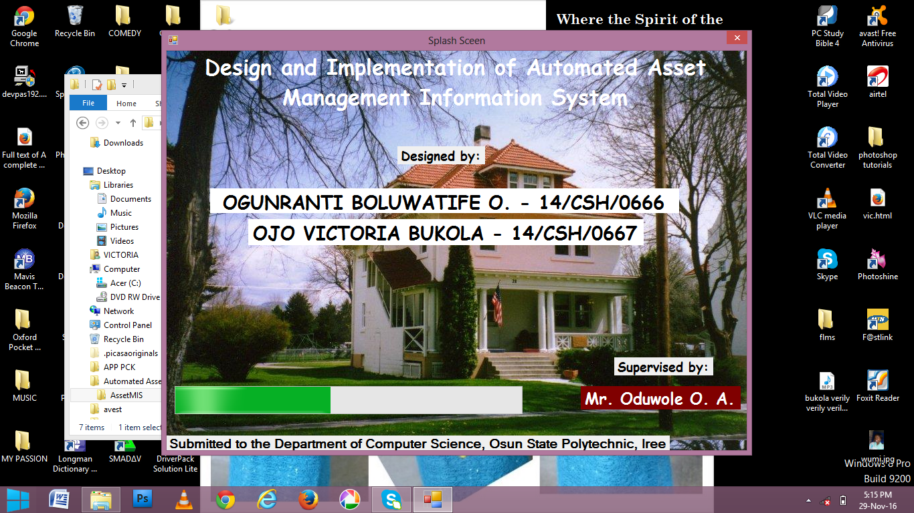

**Fig 3.1:** Splash Screen of the developed system

* + 1. **Main Page**: This page contains all the available commands and serves as a link to all other modules in the program. To access any of the menu command, click at the modules to view all the sub modules. Its structure as shown below

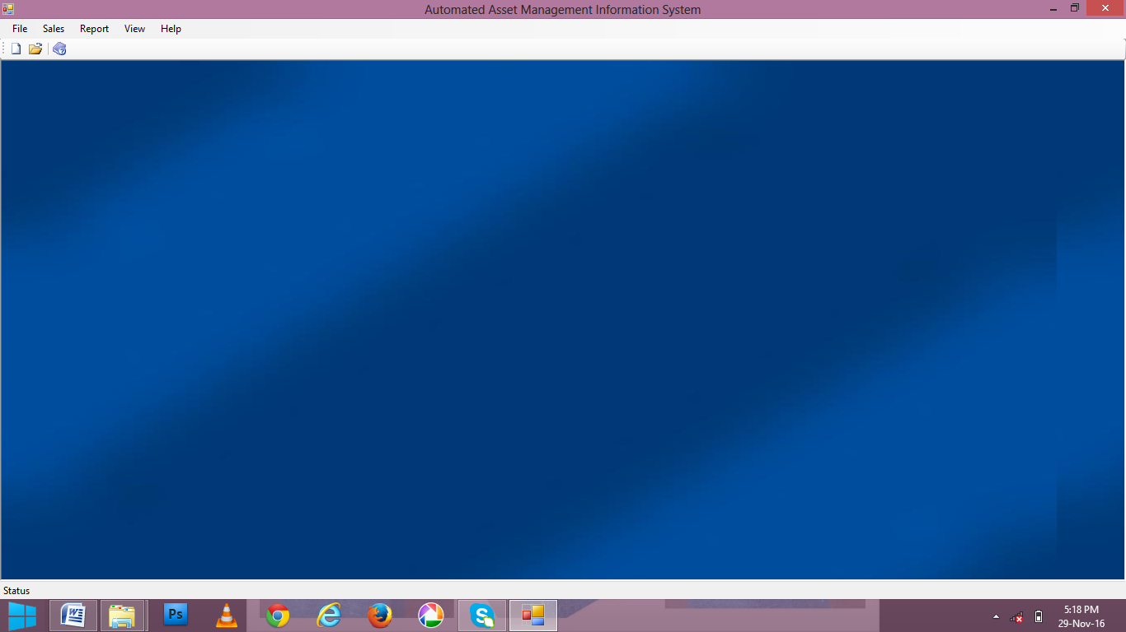

**Fig 3.2:** Home page of the developed system

* + 1. **Login Page:** This page enables the administrator to enter their username/ password. If the password entered is valid, the system will then open the program menu. But if the password is not valid the user will be denied access to the program. Its structure as shown in Fig. 3.3

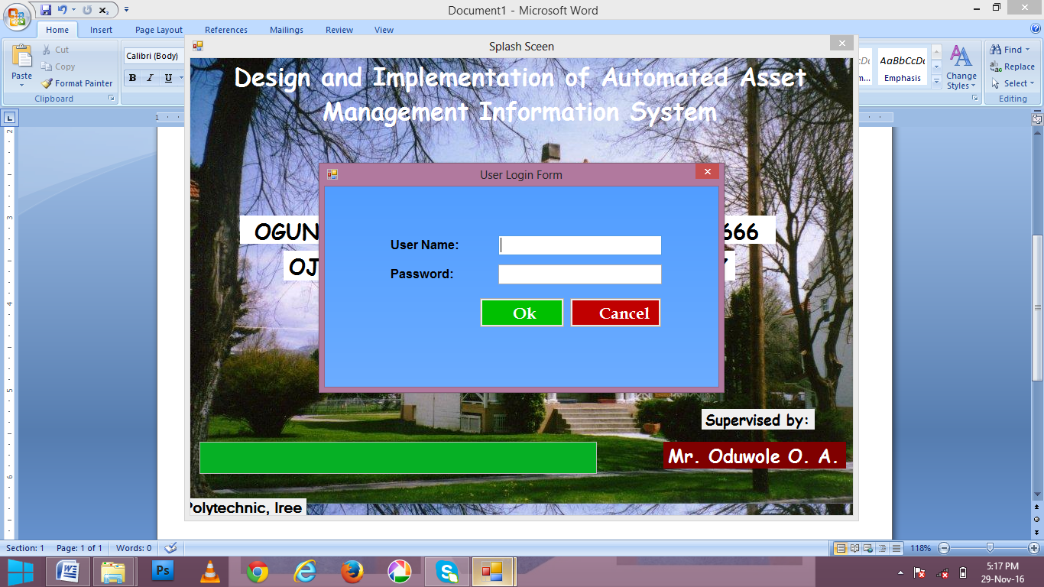

**Fig. 3.3:** Login page of the developed system

* + 1. **Asset Registration Module:** This is module allows user to save new asset, edit saved asset and delete unwanted asset. Its structure as shown in Fig. 3.4

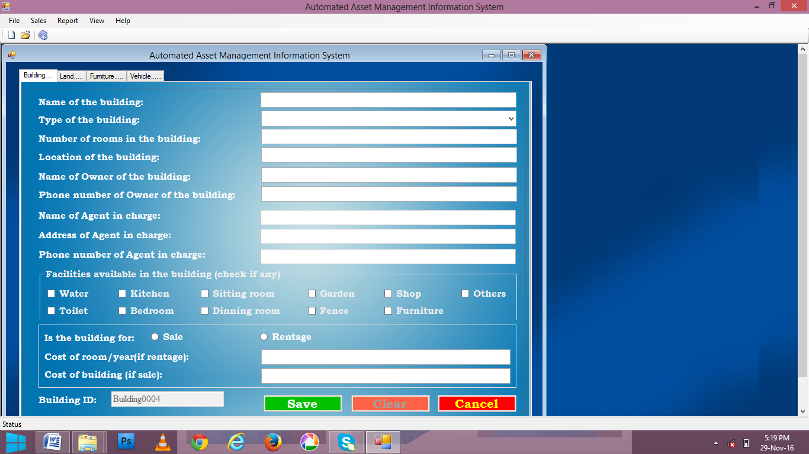

**Fig 3.4:** Asset registration Module of the developed system

* + 1. **Budget Module:** This module enables user to calculate and save budget record. Its structure as shown in Fig. 3.5

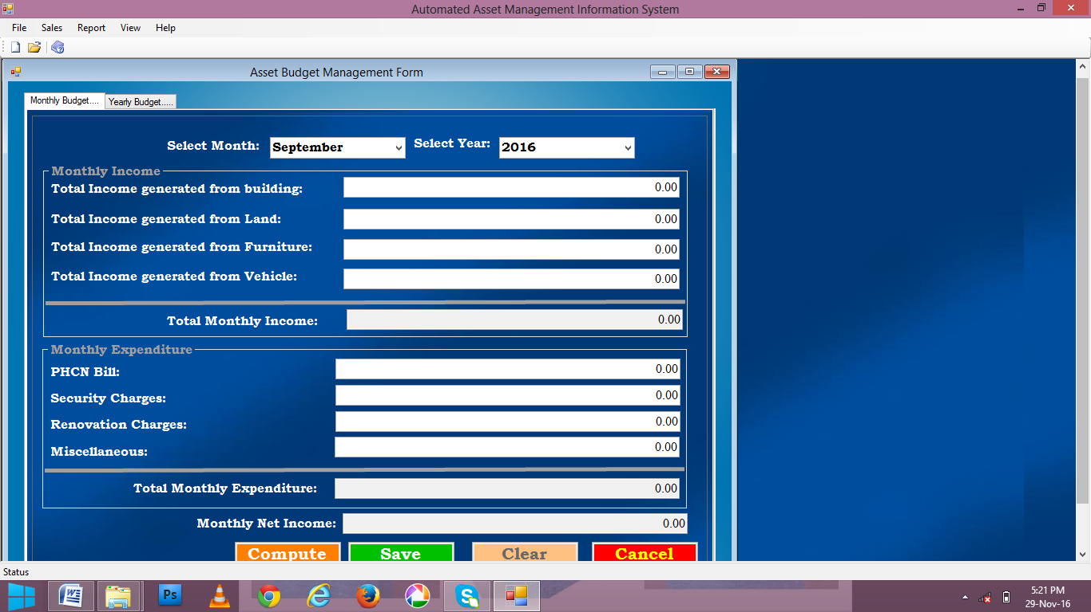

**Fig. 3.5:** Budget Module of the developed system

**3.3 SYSTEM IMPLEMETATION**

The Object Oriented (O-O) paradigm being the natural way of implementing UML designs, the implementation of the tool was done using the O-O style. The programming languages of choice were VB.NET and MS Access. The detailed documentation obtained at the detailed design stage was translated into classes of the target programming language. An attempt at separation of the graphical user interface (GUI) and the functionality was made. This was to enable the development of a loosely coupled system.

**3.2.1 Tools and Environment**

As indicated earlier on, implementation of the system was done using VB.Net and Ms Access. Ms Access was selected because it is one of the freely available software suitable for creating, modifying and deleting tables. It also offers fast access when accessing a database through the window base application interface. On the other hand, VV.Net was for fine-tuning areas of the interface that could not be handled by other applications like window base software. The purpose of choosing and using these programming languages was to achieve the general objective.

**3.4 EVALUATION OF THE DEVELOPED SYSTEM**

Performance evaluation on the developed system was carried out based on criteria. Such as

**3.4.1 Accessibility**

After the system had been tested, the result shows that the new developed system is accessible i.e the new developed system was available at any convenient time of the users and responsiveness, user can access it anytime they need it or fill like using the new developed system.

**3.4.2 Reliability**

The reliability test of the system shows relating to the performance of the system shows that the system performs in the expected way without failure.

**3.4.3 Availability**

The availability result shows that the system was available at any convenient time of the users

**3.4.4 Speed**

From the test and the result generated shows that the new developed system performs all the necessary things it supposes to perform and it does not keep the user wait. Thetest performed shows that the efficiency and effectiveness of the new developed system is very easy to use, user friendliness and fast in operation.

**3.4.3 Evaluation Methodology**

The developed system was evaluated by administering questionnaire on one hundred and twenty (120) users. The completed questionnaire were collected and used for the analysis of the result in chapter four.

**CHAPTER FOUR**

**4.0 RESULT AND DISCUSSION**

**4.1 RESULTS**

The result of the evaluation of the developed system is as presented in tables 4.1, 4.2, 4.3 and 4.4 and figures 4.1, 4.2, 4.3 and 4.4 below:

**Table 4.1:** Response of the users on the accessibility of the developed system

|  |  |  |
| --- | --- | --- |
| **The developed system is easy to access** | **Frequency** | **Percentage** |
| Strongly Agree | 75 | 63% |
| Agree | 25 | 21% |
| Disagree | 13 | 10% |
| Strongly Disagree | 7 | 6% |
| **Total** | **120** | **100%** |

**Figure 4.1:** A Graphical Representation of the newly developed system accessibility

**Table 4.2:** Response of the users on the Reliability of the developed system

|  |  |  |
| --- | --- | --- |
| **The developed system is easy to access** | **Frequency** | **Percentage** |
| Strongly Agree | 80 | 67% |
| Agree | 35 | 29% |
| Disagree | 5 | 4% |
| Strongly Disagree | - | - |
| **Total** | **120** | **100%** |

**Figure 4.2:** A Graphical Representation of the newly developed system Reliability

**Table 4.3:** Response of the users on the availability of the developed system

|  |  |  |
| --- | --- | --- |
| **The developed system is very fast in operation** | **Frequency** | **Percentage** |
| Strongly Agree | 90 | 75% |
| Agree | 22 | 18% |
| Disagree | 8 | 7% |
| Strongly Disagree | - | 0% |
| **Total** | **120** | **100%** |

**Figure 4.3:** A Graphical Representation of the newly developed system availability

**Table 4.4:** Response of the users on the speed of the developed system

|  |  |  |
| --- | --- | --- |
| **The developed system is very fast in operation** | **Frequency** | **Percentage** |
| Strongly Agree | 90 | 75% |
| Agree | 25 | 21% |
| Disagree | 5 | 4% |
| Strongly Disagree | - | 0% |
| **Total** | **120** | **100%** |

**Figure 4.4:** A Graphical Representation responses of the developed system speed

**4.2 DISCUSSION**

The table 4.1 and fig 4.1 shows that 100 agreed and 20 users disagreed that the system is easily accessible. The table 4.2 and fig 4.2 shows that 115 agreed and 5 users disagreed that the system is reliable. The table 4.3 and fig 4.3 shows that 112 agreed and 8 users disagreed that the system is available at any convenient time for the users. The table 4.4 and fig 4.4 shows that 115 agreed and 5 users disagreed that the developed system is very fast in operation. From the result shown in the table it is concluded that majority of the users agreed that the system is easy to accessible, reliable, available at any convenient time and fast in operation.

**CHAPTER FIVE**

**5.0 CONCLUSION AND RECOMMENDATION**

**5.1** **CONCLUSION**

As stated many times before along this document, assets are the backbone of an institution's day-to-day operations. In addition, these items are of high costs and require to be managed as efficiently as possible. Although this is a vital management area for businesses, in many cases it is done inefficiently. The inventory and storage, as well as the recording and reporting of assets transactions, are some of organization’s major weaknesses in regards to the management of its property, to the point that there is few to none information in this regard. Moreover, the lack of a maintenance and repair module, along with clear definitions and procedures of what constitute the disposition of damaged, obsolete or unneeded assets, represents another area that needs major improvements and/ or restructure.

In conclusion, all processes, procedures and controls regarding the management of fixed have been very inefficient As a result, many organizations does not have assets management process that can provide reliable, precise, up-to-date, and fast information about the institution's property. Furthermore, many organizations do not know what its assets, their current condition, are or how well these items are maintained.

**5.2 RECOMMENDATIONS**

After findings provided in this research and the comparison matrix presented above, it is now useful to provide some recommendations for measures to put in place and activities to be carried out. These recommendations will allow most of organization to improve the management of its assets and reduce hidden costs associated with the inefficient management that has been carried out up to this point. The following recommendations are divided in two groups. Furthermore, we also recommend the following:

1. Redefine all policies, rules, procedures and controls related to asset management, based on best practices, and the needs of the institution.
2. Planning should be based on reliable, up-to-date and concise information in order to enhance the decision-making process.
3. Create assets management manual with all information regarding the management of assets.
4. Provide training about the different asset management processes in which other departments are involved.
5. Implement a maintenance module to provide proper maintenance to the organization's assets.
6. Implementation of a new assets management process based on the criteria discussed on chapter two (2).
7. Selection and implementation of an integrated assets management system in order to make the entire process more efficient and provide reliable, up-to-date and fast information on assets.
8. Build or designate an area specifically for the storage of new and/ or surplus assets.

**REFERENCES**

Barry W. Boehm, (2007). *A spiral Model of software Development and Enhancement.* TRW Defence system Group, Oxford Publishers Ltd, England.

William D. Brady, Jr. (2001). *Software Life cycle.* Mc Tick publishers, London.

Peterson S. (2005). *All in One CISSP Asset Guide, 3rd Edition.* California: McGraw Hill Publishers.

Delaney, Epstein, Nach and Budack (2002). General Accounting principles, 2nd Edition, Cambridge University Press.

Brady P. (2001). *Introduction to Information Retrieval,* Cambridge University Press.

Kriss (1999). *Foundation of Database System.* New Delhi: Pearson Education.

Stephan Moriarty (1998). Management Accounting: Magazine for Chartered Management Accountants. McGraw Hill Publishers.

Heintz & Parry, (2002). Accounting classifications of fixed assets accounts. New York: Mc-Graw Hill Publisher.

US Department of Housing and Urban Development (1999). A historical appraisal cost.

Littrell and Thompson (1998), explained in their article, "Asset reporting: A research note" New York: Mc-Graw Hill Publisher.

Peterson (2002). Accounting for Assets, New Delhi: Pearson Education.

Dr. James Watters and Roger W. Stackpoole (2003). Computerized system in inventory

verification, Prentice Hall. Jenkins Press, London

Denver Public Schools Assets Department (2000). Assets record in keeping accurate asset management, Mc Tick publishers, London.

**APPENDIX**

**PROGRAM OUTPUT**

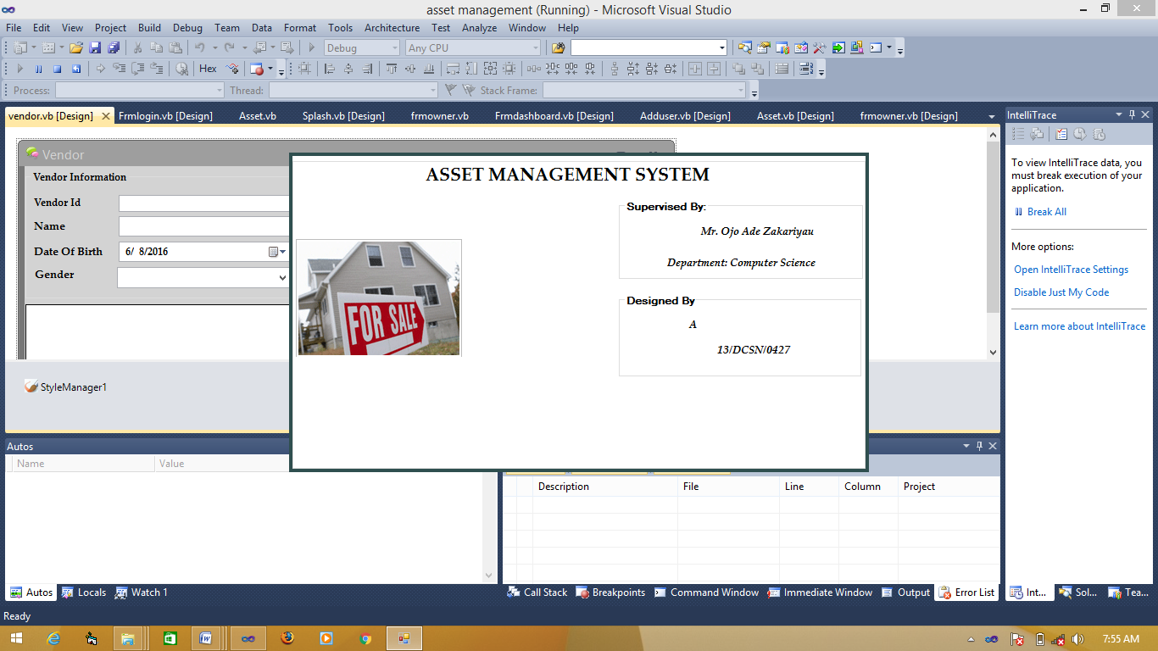

13/DCSN/1312

13/DCSN/1313

13/DCSN/1314

13/DCSN/1315

13/DCSN/1316

Mr. Y. A. Zakariyau

**Splash Page**

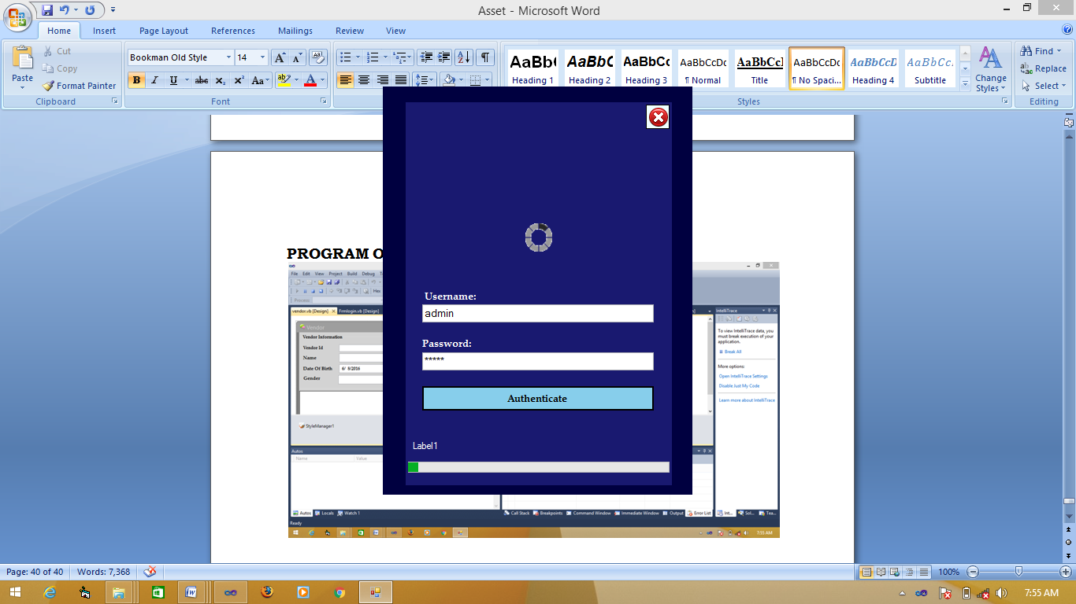

**Login Page**

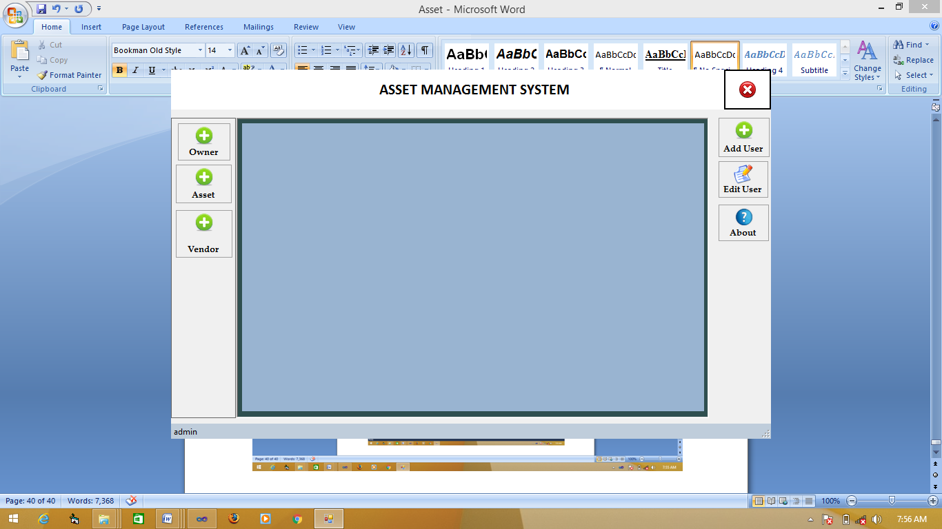

**Main Page**

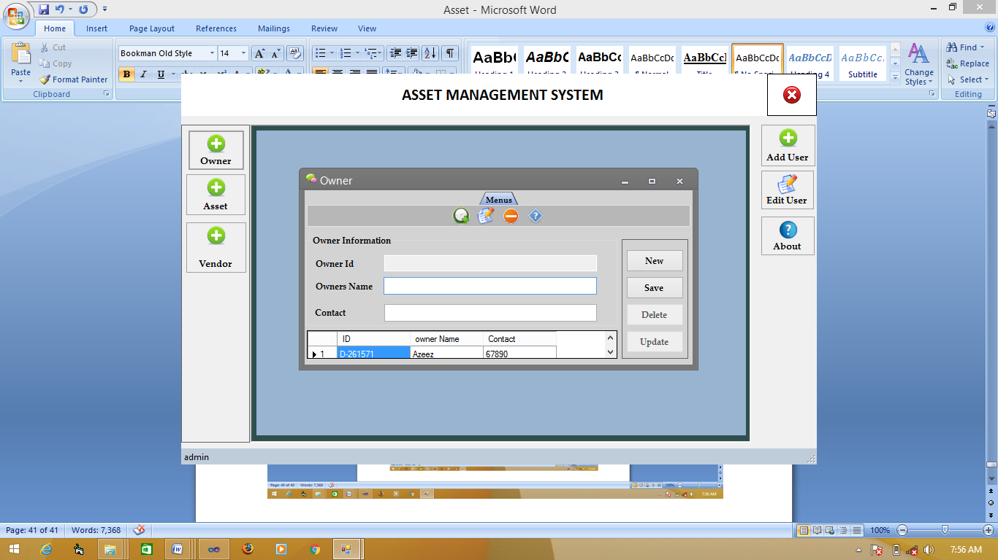

**Owner Registration Page**

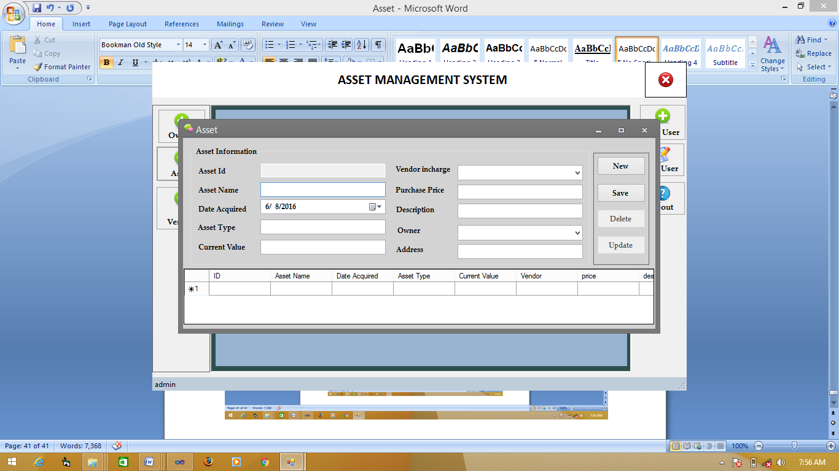

**Asset Registration Page**

**SOURCE CODE**

Imports System.Data.OleDb

Imports System.Security.Cryptography

Imports System.Text

Public Class vendor

Dim rdr As OleDbDataReader = Nothing

Dim dtable As DataTable

Dim con As OleDbConnection = Nothing

Dim adp As OleDbDataAdapter

Dim ds As DataSet

Dim cmd As OleDbCommand = Nothing

Dim dt As New DataTable

Public conStr As String = "Provider=Microsoft.ACE.OLEDB.12.0;Data Source=" + System.Environment.CurrentDirectory + "\timedatabase.accdb"

Public Shared Function GetUniqueKey(ByVal maxSize As Integer) As String

Dim chars As Char() = New Char(61) {}

chars = "123456789".ToCharArray()

Dim data As Byte() = New Byte(0) {}

Dim crypto As New RNGCryptoServiceProvider()

crypto.GetNonZeroBytes(data)

data = New Byte(maxSize - 1) {}

crypto.GetNonZeroBytes(data)

Dim result As New StringBuilder(maxSize)

For Each b As Byte In data

result.Append(chars(b Mod (chars.Length)))

Next

Return result.ToString()

End Function

Public Sub Reset()

cmbgender.Text = ""

txtadd.Text = ""

txtdocname.Text = ""

txtid.Text = ""

txtname.Text = ""

btnSave.Enabled = True

btnDelete.Enabled = False

btnUpdate_record.Enabled = False

txtname.Focus()

End Sub

Private Sub btnNewRecord_Click(ByVal sender As System.Object, ByVal e As System.EventArgs) Handles btnNewRecord.Click

Reset()

End Sub

Private Sub txtname_TextChanged(ByVal sender As System.Object, ByVal e As System.EventArgs) Handles txtname.TextChanged

End Sub

Private Sub Patient_Load(ByVal sender As System.Object, ByVal e As System.EventArgs) Handles MyBase.Load

GetData()

End Sub

Sub GetData()

Try

con = New OleDbConnection(conStr)

con.Open()

cmd = New OleDbCommand("SELECT ID, vendorname as [Vendor Name], dob as [Date of Birth], gender, phone, address from vendor order by vendorName", con)

Dim myDA As OleDbDataAdapter = New OleDbDataAdapter(cmd)

Dim myDataSet As DataSet = New DataSet()

myDA.Fill(myDataSet, "vendor")

dataGridView1.DataSource = myDataSet.Tables("vendor").DefaultView

con.Close()

Catch ex As Exception

MessageBox.Show(ex.Message, "Error", MessageBoxButtons.OK, MessageBoxIcon.Error)

End Try

End Sub

Private Sub btnSave_Click(ByVal sender As System.Object, ByVal e As System.EventArgs) Handles btnSave.Click

Try

If Len(Trim(txtname.Text)) = 0 Then

MessageBox.Show("Please enter Doctor name", "Input Error", MessageBoxButtons.OK, MessageBoxIcon.Error)

txtname.Focus()

Exit Sub

End If

txtid.Text = "P-" & GetUniqueKey(6)

con = New OleDbConnection(conStr)

con.Open()

Dim cb As String = "insert into vendor(ID, vendorname, dob,gender,phone,address) VALUES ('" & txtid.Text & "','" & txtname.Text & "','" & DateTimePicker1.Value & "','" & cmbgender.Text & "','" & txtdocname.Text & "','" & txtadd.Text & "')"

cmd = New OleDbCommand(cb)

cmd.Connection = con

cmd.ExecuteReader()

MessageBox.Show("Successfully saved", "Record", MessageBoxButtons.OK, MessageBoxIcon.Information)

btnSave.Enabled = False

Reset()

GetData()

con.Close()

Catch ex As Exception

MessageBox.Show(ex.Message, "Error", MessageBoxButtons.OK, MessageBoxIcon.Error)

End Try

End Sub

Private Sub btnDelete_Click(ByVal sender As System.Object, ByVal e As System.EventArgs) Handles btnDelete.Click

Try

If MessageBox.Show("Do you really want to delete this record?", "Confirmation", MessageBoxButtons.YesNo, MessageBoxIcon.Warning) = Windows.Forms.DialogResult.Yes Then

DeleteRecord()

End If

Catch ex As Exception

MessageBox.Show(ex.Message, "Error", MessageBoxButtons.OK, MessageBoxIcon.Error)

End Try

End Sub

Public Sub DeleteRecord()

Try

Dim RowsAffected As Integer = 0

con = New OleDbConnection(conStr)

con.Open()

Dim cq As String = "delete from vendor where ID='" & txtid.Text & "'"

cmd = New OleDbCommand(cq)

cmd.Connection = con

RowsAffected = cmd.ExecuteNonQuery()

If RowsAffected > 0 Then

MessageBox.Show("Successfully deleted", "Record", MessageBoxButtons.OK, MessageBoxIcon.Information)

Reset()

GetData()

Else

MessageBox.Show("No record found", "Sorry", MessageBoxButtons.OK, MessageBoxIcon.Information)

Reset()

End If

con.Close()

Catch ex As Exception

MessageBox.Show(ex.Message, "Error", MessageBoxButtons.OK, MessageBoxIcon.Error)

End Try

End Sub

Private Sub btnUpdate_record_Click(ByVal sender As System.Object, ByVal e As System.EventArgs) Handles btnUpdate_record.Click

Try

con = New OleDbConnection(conStr)

con.Open()

Dim cb As String = "Update vendor set vendorname='" & txtname.Text & "', dob='" & DateTimePicker1.Value & "', gender='" & cmbgender.Text & "', phone = '" & txtdocname.Text & "', address='" & txtadd.Text & "' where ID='" & txtid.Text & "'"

cmd = New OleDbCommand(cb)

cmd.Connection = con

cmd.ExecuteReader()

MessageBox.Show("Successfully updated", "Record", MessageBoxButtons.OK, MessageBoxIcon.Information)

btnUpdate_record.Enabled = False

Reset()

GetData()

con.Close()

Catch ex As Exception

MessageBox.Show(ex.Message, "Error", MessageBoxButtons.OK, MessageBoxIcon.Error)

End Try

End Sub

Private Sub dataGridView1_RowHeaderMouseClick(ByVal sender As Object, ByVal e As System.Windows.Forms.DataGridViewCellMouseEventArgs) Handles dataGridView1.RowHeaderMouseClick

Try

Dim dr As DataGridViewRow = dataGridView1.SelectedRows(0)

txtid.Text = dr.Cells(0).Value.ToString()

txtname.Text = dr.Cells(1).Value.ToString()

DateTimePicker1.Value = dr.Cells(2).Value.ToString()

cmbgender.Text = dr.Cells(3).Value.ToString()

txtdocname.Text = dr.Cells(4).Value.ToString()

txtadd.Text = dr.Cells(5).Value.ToString()

btnUpdate_record.Enabled = True

btnDelete.Enabled = True

btnSave.Enabled = False

txtname.Focus()

Catch ex As Exception

MessageBox.Show(ex.Message, "Error", MessageBoxButtons.OK, MessageBoxIcon.Error)

End Try

End Sub

Private Sub dataGridView1_RowPostPaint(ByVal sender As Object, ByVal e As System.Windows.Forms.DataGridViewRowPostPaintEventArgs) Handles dataGridView1.RowPostPaint

Dim strRowNumber As String = (e.RowIndex + 1).ToString()

Dim size As SizeF = e.Graphics.MeasureString(strRowNumber, Me.Font)

If dataGridView1.RowHeadersWidth < Convert.ToInt32((size.Width + 20)) Then

dataGridView1.RowHeadersWidth = Convert.ToInt32((size.Width + 20))

End If

Dim b As Brush = SystemBrushes.ControlText

e.Graphics.DrawString(strRowNumber, Me.Font, b, e.RowBounds.Location.X + 15, e.RowBounds.Location.Y + ((e.RowBounds.Height - size.Height) / 2))

End Sub

Private Sub GroupBoxGuestInfo_Enter(ByVal sender As System.Object, ByVal e As System.EventArgs) Handles GroupBoxGuestInfo.Enter

End Sub

End Class